**Batch: B-1 Roll No.: 16010122104**

**Experiment / assignment / tutorial No. 2**

**Grade: AA / AB / BB / BC / CC / CD /DD**

**Signature of the Staff In-charge with date**

|  |
| --- |
| **Title: Mapping ER and EER model to Relational Model** |

**Objective:**  To apply mapping techniques to map ER and EER diagram to its equivalent relational model _____________________________________________________________

**Expected Outcome of Experiment:**

**CO 2:** To convert E-R into relational table populate a relational database and formulate SQL queries on the data .Use SQL for query and database.

_____________________________________________________________

**Books/ Journals/ Websites referred:**

1. G. K. Gupta :”Database Management Systems”, McGraw – Hill
2. Korth, Slberchatz, Sudarshan : “Database Systems Concept”, 6th Edition , McGraw Hill
3. Elmasri and Navathe, “Fundamentals of Database Systems”, 5thEdition, PEARSON Education.

_____________________________________________________________

**Pre Lab/ Prior Concepts:**

**Relational Model:**

Relational Model represents the database as a collection of relations. Relational model can be thought of as table of values, each row in the table represents collection of related data values. In the relational model, each row in the table represents the fact that corresponds real world entity or relationship. The table name and column name are used to interpret the meanings of the values in each row.

In formal relational model terminology, a row is called tuple, a column header is called an attribute, and table is called a relation. The data type describing the types of values that can appear in each column is represented by a domain of possible values. Thus Relation is set of tuples.

**Procedure for doing the Relation Model (ER to Relational Mapping)**

1. Mapping of Regular Entity
   * For each regular (strong) entity type in the ER schema, create a relation R that includes all the simple attributes of E.
   * Choose one of the key attributes of E as the primary key for the relation
2. Mapping of Weak Entity
   * For each weak entity type W in the ER schema with owner entity type E, create a relation R and include all attributes of the weak entity as attributes of the new relation R.
   * Then, include the primary key of the owner entity as foreign key attributes of R
   * The primary key of R is the combination of the primary key(s) of the owner(s) and the partial key of the weak entity type W, if any.
3. Mapping of Binary 1:1 Relationship Types
   * For each 1:1 relationship type identify the entities participating in the relationship. There are two possible approaches below:
   * a) Foreign Key approach:

Choose one of the relations and include a foreign key in one relation (S) which is the primary key of the other relation (T). It is better to choose an entity type with total participation in the relationship in the role of S.

* + b) Merged relation option:

An alternate mapping of a 1:1 relationship type is possible by merging the two entity types and the relationship into a single relation. This may be appropriate when both participations are total.

1. Mapping of Binary 1:N Relationship Types
   * For each regular 1:N relationship type R, identify the relation S, which is the entity on the N-side of the relationship.
   * Include as foreign key in S the primary key of the relation which is on the 1 side of the relationship
   * Include any simple attributes of the 1:N relation type as attributes of S.
2. Mapping of Binary M:N Relationship Types
   * For each M:N relationship type, create a new relation S to represent the relationship
   * Include as foreign key attributes in S the primary keys of the entities on each side of the relationship; the combination of the two primary keys will form the primary key of S

- Also include any simple attributes of the M:N relationship type as attributes of S.

1. Mapping of Multivalued Attributes.
   * For each multivalued attribute A, create a new relation. This relation will include an attribute corresponding to the multi-valued attribute, plus the primary key attribute of the relation that has the multi-valued attribute, K
   * The primary key attribute of the relation is the foreign key representing the relationship between the entity and the multi-valued relation
   * The primary key of R is the combination of A and K
2. Mapping of N-ary Relationship Types
   * For each n-ary relationship type R, where n>2, create a new relation S to represent the relationship.
   * Include as foreign key attributes in S the primary keys of the relations that represent the participating entities
   * Also include any simple attributes of the n-ary relationship type as attributes of S
3. Options for Mapping Specialization or Generalization

* Convert each specialization with m subclasses {S1, S2,….,Sm} and generalized superclass C, where the attributes of C are {k,a1,…an} and k is the (primary) key, into relational schemas using one of the four following options:

Option 8A: Multiple relations-Superclass and subclasses.

Option 8B: Multiple relations-Subclass relations only.

Option 8C: Single relation with one type attribute.

Option 8D: Single relation with multiple type attributes.

**Company Database ER model**

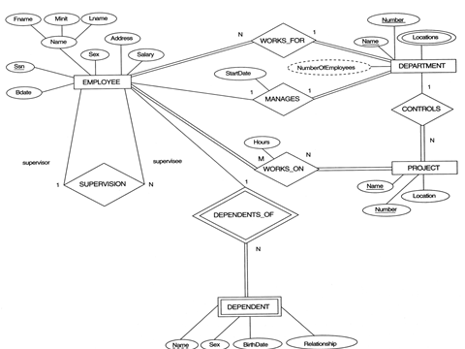

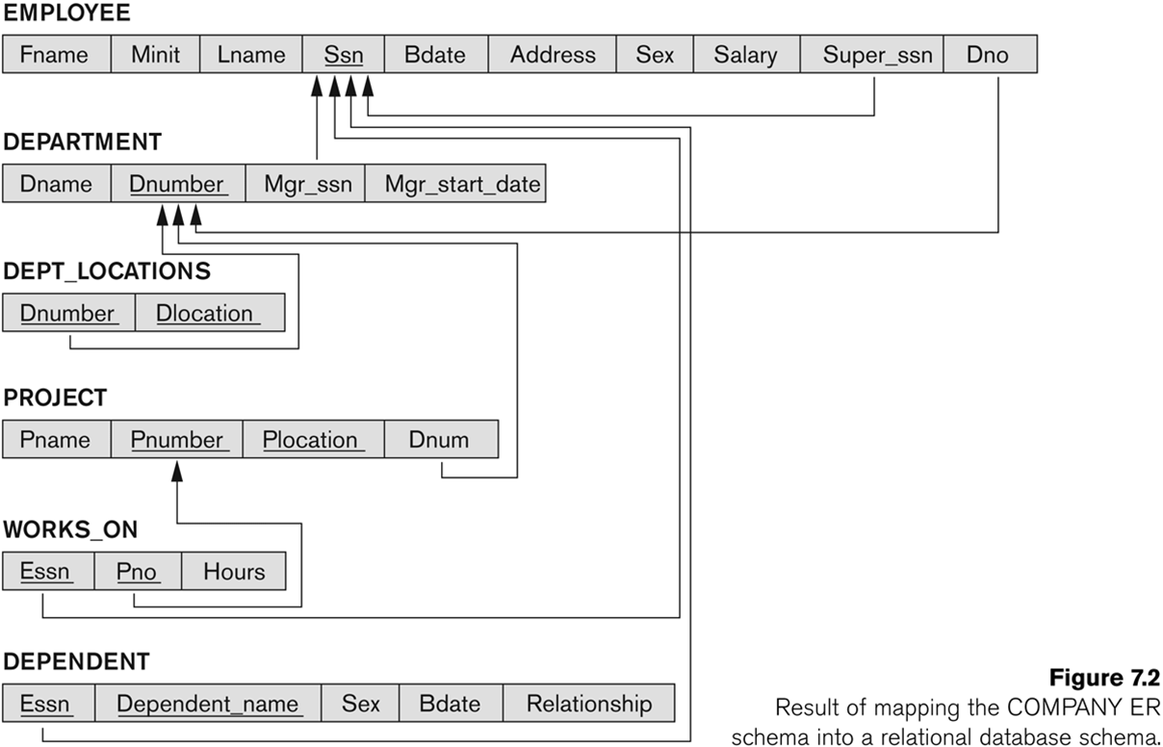

1. Mapping of Union Types (Categories).
   * For mapping a category whose defining superclass have different keys, it is customary to specify a new key attribute, called a surrogate key, when creating a relation to correspond to the category.
   * In the example below, create a relation OWNER to correspond to the OWNER category and include any attributes of the category in this relation. The primary key of the OWNER relation is the surrogate key, which we called OwnerId.

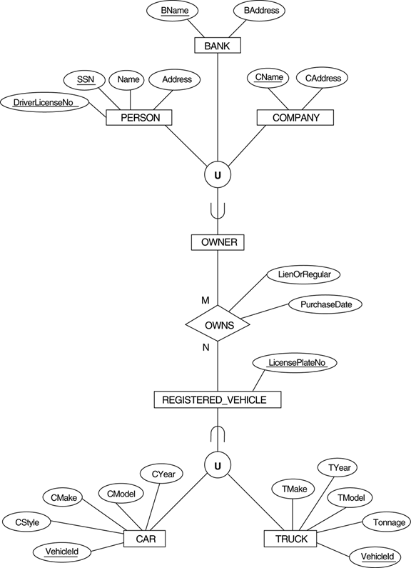

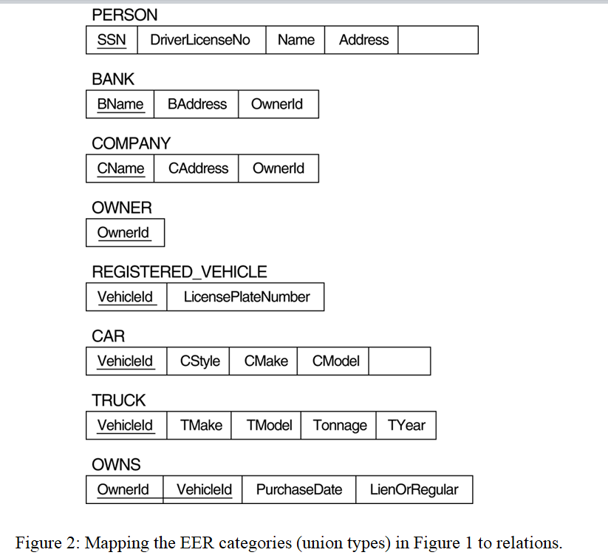

**Case Study considered for Database Design:**

Result Management System

**Relational Model for Project:**

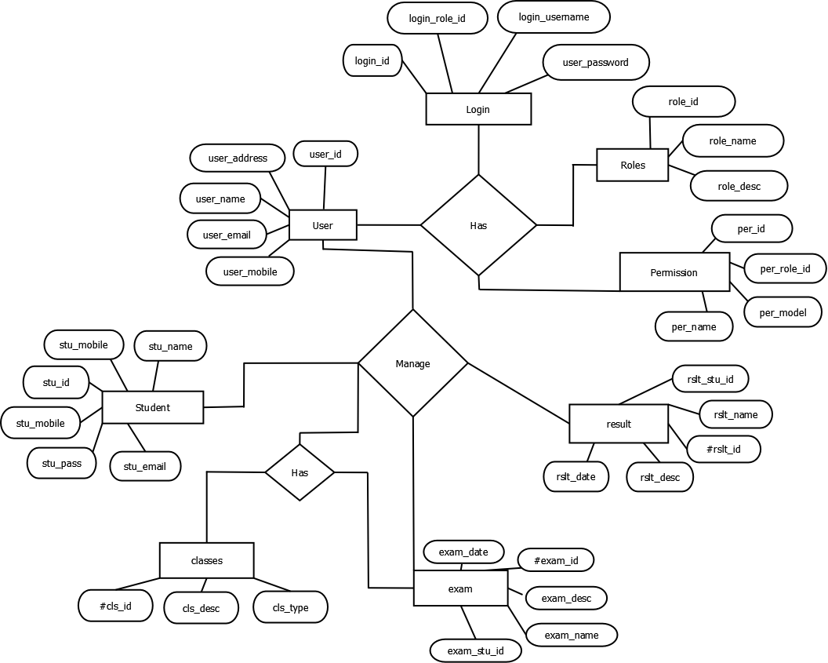

**Post Lab Questions:**

**1. Draw the MENU entity as a supertype of the PROMOTIONAL, REGULAR, and OTHER entities. The UID of MENU is code. MENU is related to FOOD ITEM through this relation-ship: each MENU may contain one or more FOOD ITEMs, and each FOOD ITEM must be listed on one and only one MENU. The UID of FOOD ITEM is a barred UID using its attribute “number”. Add appropriate attributes to each entity and draw a relational model for it.**

+-------------------------+

| MENU |

+-------------------------+

| code (PK) |

| name |

| type |

| price |

+-------------------------+

|

|

+-----|------+

| |

v v

+-------------------------+

| PROMOTIONAL |

+-------------------------+

| code (FK, PK) |

| promotionDetails |

| discountPercentage |

+-------------------------+

+-------------------------+

| REGULAR |

+-------------------------+

| code (FK, PK) |

| regularDetails |

| dailySpecial |

+-------------------------+

+-------------------------+

| OTHER |

+-------------------------+

| code (FK, PK) |

| otherDetails |

| specialInstructions |

+-------------------------+

+-------------------------+

| FOOD ITEM |

+-------------------------+

| number (PK) |

| name |

| description |

| price |

+-------------------------+

|

|

+-----|------+

| |

v v

+-------------------------+

| MENU_ITEM |

+-------------------------+

| menuCode (FK, PK) |

| foodItemNumber (FK, PK) |

+-------------------------+

**2. A field in a database table whose values are the same as the primary key of another table is called:**

A. A foreign key

B. A primary key

C. A secondary key

D. A candidate key

E. An alternate key

**3. The mapping of relationship depends on**

A. Type of relationship

B. No. of records

C. No. of attributes

D. No. of regular entities

1. **Answer to Question 2: A. A foreign key**
2. **Answer to Question 3: A. Type of relationship**

**Conclusion:**

This experiment enabled a systematic understanding of Data requirements of application and EER diagram design, laying the groundwork for effective and optimized database development